

Structural Design

(Inside View)

**Vertical corrugation**

Design#:

**181198-01_B**

Customer:

**DeMet's Candy**

Description:

**RSC-6.2oz Minis Standup Pouch**

**[Left-Hand 1/8" Gap]**

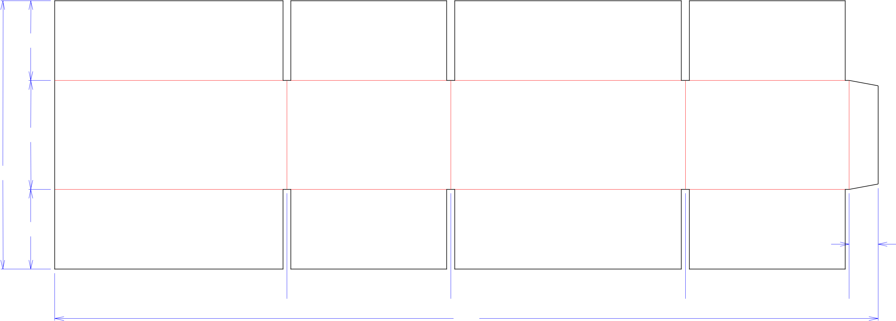

313*/*16

53*/*16

1213*/*16

313*/*16

13*/*8

 111*/*16  713*/*16  113*/*16  713*/*16 

391*/*4

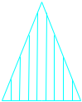

Cut Crease Crease with Matrix Cut Crease Half Knife Cut Tear Tape Perforation



**SINGLE-OUT DRAWING**

Qty/Unit:

Style: **RSC**

Board: **32CK**

Combination: **35HP - 23M - 35HP**

I.D. : **11 x 7+5/8 x 4+7/8**

Area of Blank - Waste : **3.35 sq. ft.**

Waste on Blank : **4.14%**

Finished Piece Weight: **0.35 lbs./159.22g**

Over-all Blank: **12+13/16 x 39+1/4**

Notes:

**MINI**

Revision Info: **[B] 12/05/2018**

**customer change AG**

Designer: **Alan Groff**

Designright and Copyright of DS Smith Corrugated Packaging Ltd. This technical Specification is subject to Manufacturing tolerances. Drawing dimensions shown are crease to crease. Date printed: 12/05/2018